**UNSUPERVISED FRAUD DETECTION MODEL REPORT**

NY Property Data

February 13, 2020



Prepared by Team 7:

Ji Jie

Joycy Liu

Angela Ma

Emma Yang

Jenny Zhang

Wanqiu Zheng

Xindi Zhu

**Content**

**1. Executive Summary** **3**

**2. Description of Data** **4**

**3. Data Cleaning** **7**

**4. Variable Creation** **10**

**5. Dimensionality Reduction** **11**

**6. Algorithms** **13**

Method 1

Method 2

Combined Score

**7. Results** **15**

Score Distributions

Top Ten Properties: Research & Explanations

**8****. Conclusion** **30**

**9****. Appendix** **31**

# **1. Executive Summary**

The purpose of this project is to look for anomalies among property records in the “Property Valuation and Assessment Data” file using unsupervised models and find out potential fraudulent properties through investigating further on the top ten most possible properties to have committed property tax frauds and researching on reasons that these properties turn out to be anomalous and therefore detected in the models.

The “Property Valuation and Assessment Data” file is a real estate assessment property dataset that consists of properties located in New York City. The document is mainly used to calculate property tax and grant eligibility to the properties that qualify for exemptions and/or abatements. The file is updated annually and collected and entered by the City employees such as property assessors and property tax specialists. The properties in the file were assessed in November 2010 and were from 5 main areas including Manhattan, Bronx, Brooklyn, Queens, and Staten Island.

The report begins with a detailed description of the dataset. The full data quality assessment is included as an appendix of this report. As for the size of the file, the dataset has 32 fields, including both numerical and categorical fields, and 1,070,994 records. Among the 32 fields, 14 of them are numerical fields while 18 are categorical.

Followed by the description of data and distributions, the report explains how each numerical variable has been cleaned and filled in for missing values and zero values. We also included an additional 45 variables we calculated and utilized in the model. All data used are then converted into z scores in order to be compared on the same scale. Principal component analysis (PCA) is performed after the conversion to remove correlations, and dimensions are set to be reduced to six, by our choice. Then the six dimensions are again z-scaled, ready to be used for the models.

As for the detection process, we used two methods to select anomalous properties. The first method, heuristic algorithm, calculates the distance of z-scale from the origin. The second method is the autoencoder. Both methods give a score for each record where a higher score indicates a more abnormal record. We decided to combine the two methods by giving their ranks equal weight, 50%, to generate a combined score with quantile binning.

Based on the new combined score, we selected the top ten properties with the highest anomaly score to further investigate. Through further research, some properties have reasonable explanations such as government properties for high anomaly scores. From a conservative point of view to prevent frauds, there are still six properties that seem suspicious after research and therefore worth more professional investigation for potential property tax frauds.

# **2. Description of Data**

**2.1 Description**

The dataset represents the property valuation and assessment data of New York City. The data is mainly used for property assessments in NYC, calculating property tax and granting eligibility to the properties that qualify for exemptions and/or abatements. It is provided by the Department of Finance on NYC Open Data, and the properties in the file were assessed in November 2010. There are 32 columns and 1,070,994 records in this dataset.

**2.2 Summary Statistics**

**Numerical variables:**

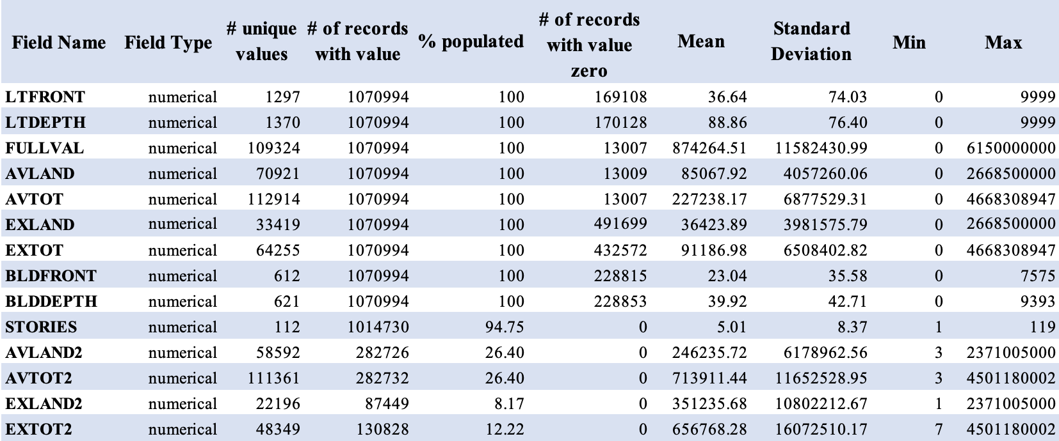

**Categorical Variables:**

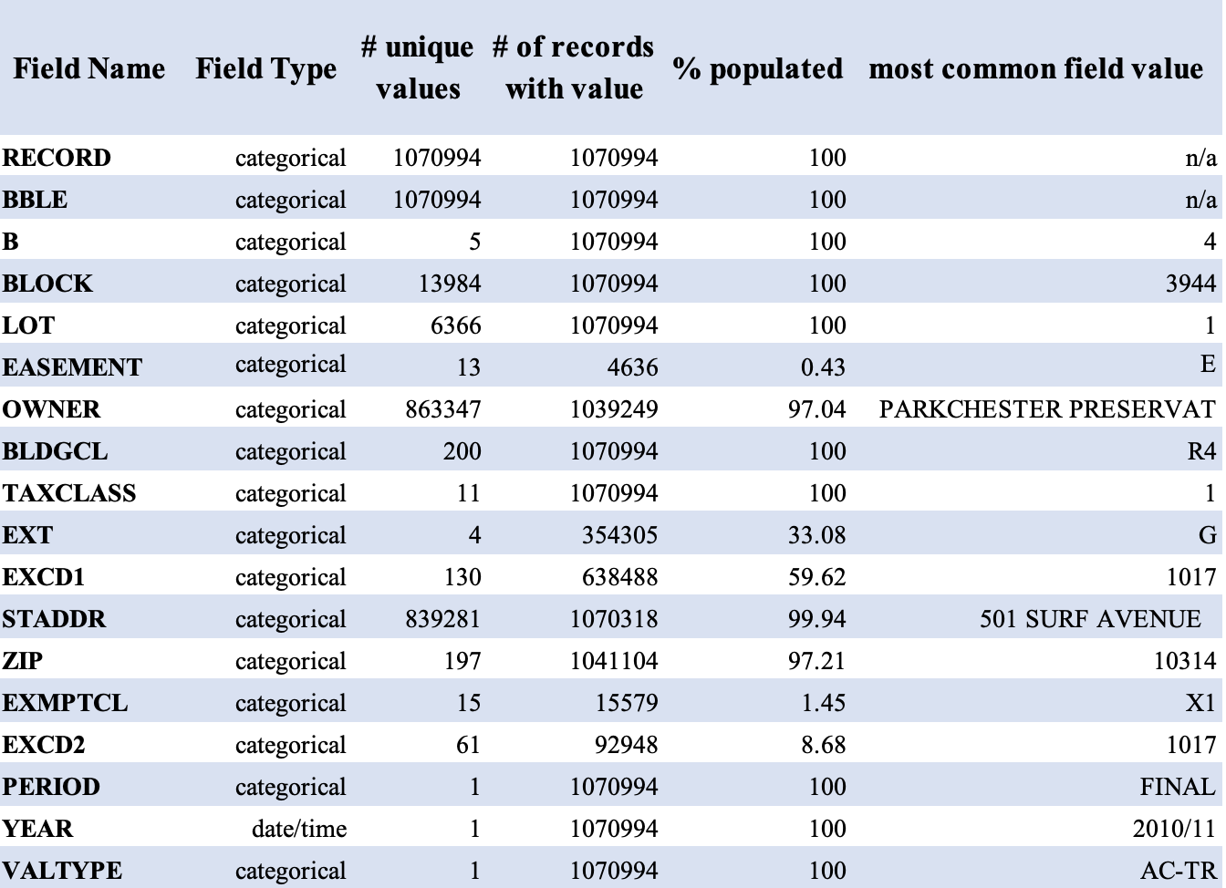

**2.3 Variable Distributions**

There are a total of 32 variables given in the dataset although only three of the distributions, FULLVAL, AVLAND, and AVTOT, are shown below. For each of the detailed descriptions and distributions, please refer to the data quality report in the appendix at the end.

**Field Name:** **FULLVAL**

**Description:** FULLVAL represents the market value of the property. There are 109,324 unique values and no missing values. There are 13,007 zero values that will be filled in with reasonable values. The mean is 874,264.5 and the standard deviation is 11,582,431. For better demonstration, we kept the data that have FULLVAL greater than 2,000,000, and the data in the histogram is 96.29% populated among the records with values.

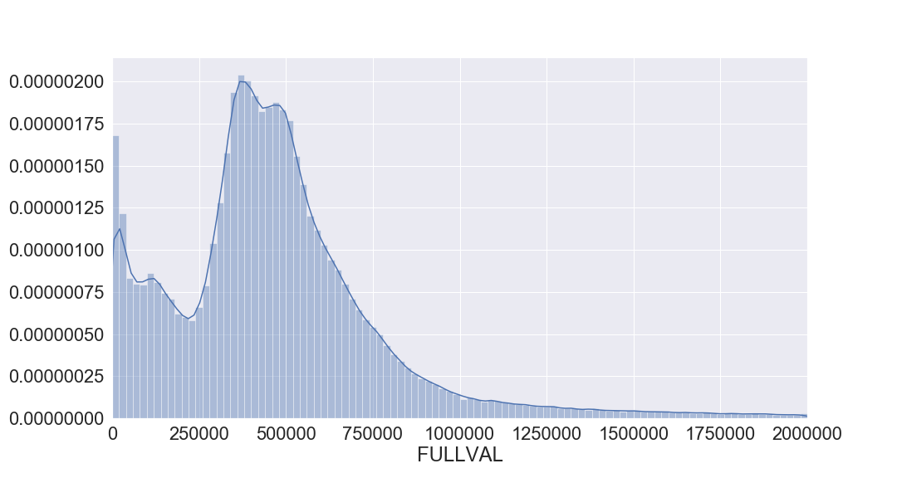

**Field Name: AVLAND**

**Description:** AVLAND represents the actual land value of the property. There are 70,921 unique values and no missing values. There are 13,009 zero values that will be filled in with reasonable values. The mean is 85,067.9 and the standard deviation is 4,057,260. For better demonstration, we kept the data that have AVLAND greater than 60,000, and the data in the histogram is 91.61% populated among the records with values.

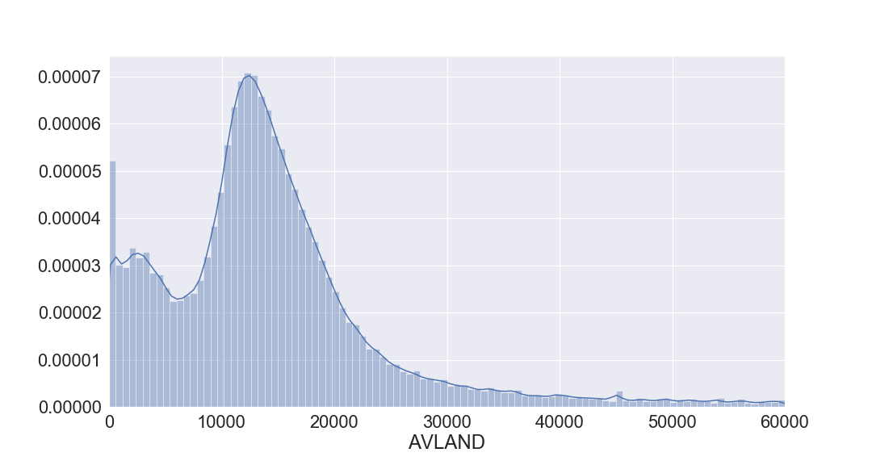

**Field Name:** **AVTOT**

**Description:** AVTOT represents the actual total value of the property. There are 112,914 unique values and no missing values. There are 13,007 zero values that will be filled in with reasonable values. The mean is 227,238.2 and the standard deviation is 6,877,529. For better demonstration, we kept the data that have AVTOT greater than 160,000, and the data the histogram is 90.05% populated among the records with values.

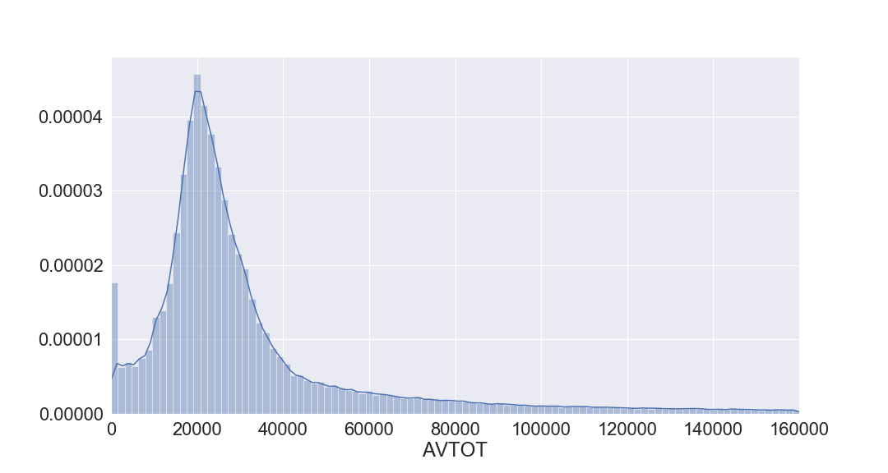

# **3. Data Cleaning**

There are nine variables we used directly from the dataset to get started on the fraud detection process: ZIP, STORIES, FULLVAL, AVLAND, AVTOT, LTFRONT, LTDEPTH, BLDFRONT, BLDDEPTH. As for data cleaning, we tried to fill in missing values and zero values in these nine variables using logical thinking and reasonable arrangements.

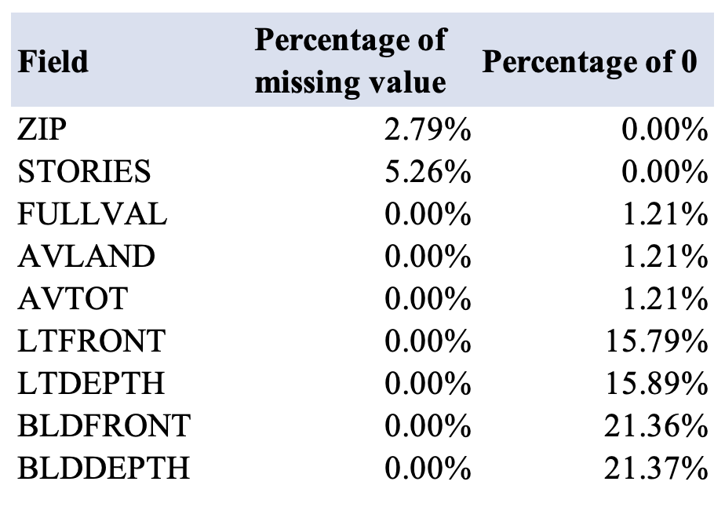

**ZIP**

There are 20,890 missing values, which is around 2.80% of the total records, for this ZIP field. For the missing ZIPs in the dataset, we applied the street address field (STADDR), which contains 676 missing values, around 0.06% of total records, in Google Maps API to find the corresponding zip code. For ZIPs missing both ZIP and STADDR values or those Google Maps API could not return the zip code due to ambiguous street address, we aggregated ZIP by BLOCK and B, and used the mode value of each group to fill in the missing zip-codes.

**STORIES**

For the missing values in STORIES, we filtered out all the records with valid STORIES value and grouped them by TAXCLASS. The reason for this choice is due to the definition and classification of TAXCLASS. Property in NYC is divided into 4 classes:

* Class 1: Most residential property of up to three units and most condominiums that are not more than three stories.
* Class 2: All other property that is not in Class 1 and is primarily residential (rentals, cooperatives and condominiums).
  + Sub-Class 2a (4 - 6 unit rental building)
  + Sub-Class 2b (7 - 10 unit rental building)
  + Sub-Class 2c (2 - 10 unit cooperative or condominium)
  + Class 2 (11 units or more)
* Class 3: Most utility property.
* Class 4: All commercial and industrial properties and all other properties not included in tax classes 1, 2 or 3.

Therefore, we filled in the missing values with the mode, which is the most common value, in each group.

**FULLVAL**

FULLVAL only has zero values but no null values. However, zero values do not make sense in FULLVAL and the mean will be distorted by the zero values in FULLVAL, so all zero values have to be replaced with null values and later filled with positive values. The first step is to differentiate groups with more than 5 records from the rest after grouped by TAXCLASS and B and assign a label for those groups. For groups that have more than five records, we used the median aggregated by TAXCLASS and B to replace the zero values. For groups that have fewer than 5 records, we used the median aggregated by only TAXCLASS to replace the zero values.

**AVLAND**

Similar to FULLVAL, AVLAND only has zero values but no null values. However, zero values do not make sense in AVLAND, so all zero values have to be replaced and filled with positive values. We first grouped by TAXCLASS and B to see how many records are within each group. For groups that have more than 5 records, we used the median aggregated by TAXCLASS and B to replace the zero values. For groups that have fewer than 5 records, we used the median aggregated by only TAXCLASS to replace the zero values.

**AVTOT**

Similar to FULLVAL, AVTOT only has zero values but no null values. However, zero values do not make sense in AVTOT, so all zero values have to be replaced and filled with positive values. We first grouped by TAXCLASS and B to see how many records are within each group. For groups that have more than 5 records, we used the median aggregated by TAXCLASS and B to replace the zero values. For groups that have fewer than 5 records, we used the median aggregated by only TAXCLASS to replace the zero values.

**LTFRONT**

We first separated the original data set into two groups: LTFRONT= 0 and LTFRONT ≠ 0. There are about 15.79 % of the records that have zero values, which were considered as missing values that needed to be filled. We used the median of "LTFRONT ≠ 0” group aggregated by ZIP and TAXCLASS that has records more than 5. For the group that has fewer than 5 records, we then used the median of aggregated by B & TAXCLASS that has more than 5 records. For the group that still has fewer than 5 records, we then used the median of aggregated by only TAXCLASS.

**LTDEPTH**

We used similar steps as LTFRONT. We first separated the original dataset into two groups: LTDEPTH=0 and LTDEPTH ≠ 0. There are about 15.89 % of records that have value 0, which we consider as missing values. We used the median of "LTDEPTH ≠ 0” group aggregated by ZIP & TAXCLASS that has records more than 5. For the group that has fewer than 5 records, we then used the median of aggregated by B and TAXCLASS that has more than 5 records. For the group that still has fewer than 5 records, we used the median aggregated by TAXCLASS.

**BLDFRONT**

We first separated the original dataset into two groups: BLDFRONT=0 and BLDFRONT ≠ 0. To fill in the BLDFRONT that has zero values (missing values), we used the median of "BLDRONT ≠ 0” group aggregated by ZIP and TAXCLASS that has records more than 5; if the group has fewer than 5 records, we then used the median of aggregated by B and TAXCLASS that has records more than 5; if the group has fewer than 5 records, we then used the median of aggregated by TAXCLASS.

**BLDDEPTH**

We then separated the original dataset into two groups: BLDDEPTH=0 and BLDDEPTH ≠ 0. To fill in the BLDDEPTH that has zero values (missing values), we used the median of "BLDDEPTH ≠ 0” group aggregated by ZIP and TAXCLASS that has records more than 5; if the group has fewer than 5 records, we then used the non-zero median of aggregated by B and TAXCLASS that has records more than 5; if the group has fewer than 5 records, we then used the median of aggregated by TAXCLASS.

# **4. Variable Creation**

For the model building process to detect potential property frauds in the dataset, we created 45 new variables with the 11 variables in the original dataset, including LTFRONT, LTDEPTH, BLDFRONT, BLDDEPTH, STORIES, ZIP, TAXCLASS, B, FULLVAL, AVLAND, AVTOT.

The variables that we created were all different transformations of three important variables as the following:

$V_{1}$ = FULLVAL – the full value of the building

$V_{2}$ = AVLAND – the assessed value of land

$V_{3}$ = AVTOT – the assessed value of property

The steps for creating these 45 variables are as follows:

1. Create three sizes for each property

• $V_{4}$ = LOTAREA = LTFRONT * LTDEPTH

• $V_{5}$ = BLDAREA = BLDFRONT * BLDDEPTH

• $V_{6}$ = BLDVOL = BLDAREA* STORIES

2. Create 9 variables by normalizing FULLVALUE, AVTOT, AVLAND, respectively, by the LOTAREA, BLDAREA and BLDVOL for each record

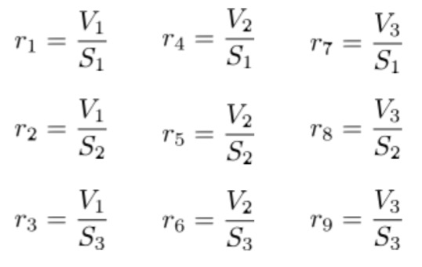

3. Group above nine ratios by 5 criteria (ZIP5, ZIP3, TAXCLASS, B, ALL), in order to compare the ratios with properties under similar condition. The meanings of the 5 criteria are as follows:

a. ZIP5 – zip code

b. ZIP3 – 3-digit zip code

c. TAXCLASS – tax class of the property

d. B – borough

e. ALL – grouped by ZIP, TAXCLASS, and B.

4. Obtain the averages of the nine ratios for each group in step 4;

5. Divide each of the nine ratios by the mean ratio value in that group based on ZIP5, ZIP3, TAXCLASS, B and ALL.

For each property record, we ended up with 45 variables which would be used in calculating the fraud score for each property later in the process. Since we expected similar ratios of the property value to property area for properties in a given location and building type, we performed a Principal Components Analysis (PCA) for these 45 variables to reduce dimensionality as the following step.

##### 5. **Dimensionality Reduction**

After filling in the missing values for the original fields in the dataset and creating new variables, we had 45 fields to begin with for the models. However, there might be some collinearity among these variables. We decided to reduce the dimensionality by performing the Principal Components Analysis (PCA) on the new dataset.

PCA is a statistical procedure that uses an orthogonal transformation to convert a set of observations of possibly correlated variables. It extracts variables that are linearly uncorrelated and combine them into a set of values of variables which is called principal components. The first principal component accounts for as much of the variability in the data as possible. And for each succeeding component, it accounts for as much of the remaining variability in the data as possible. PCA is a dimensionality reduction or data compress method. The goal of PCA is to reduce dimensionality, simply put, from a larger number of variables to a smaller number of non-dependent variables.

However, before we performed the PCA, we needed to perform the Z scale first. It is important to normalize the data because the original predictors can be on a different scale and can contribute significantly differently towards the variance, which has an impact on PCA. Below is how we do the normalization by Z scale. After we scaled the data, we can measure the “outlierness” of a record by looking at its distance from the origin.

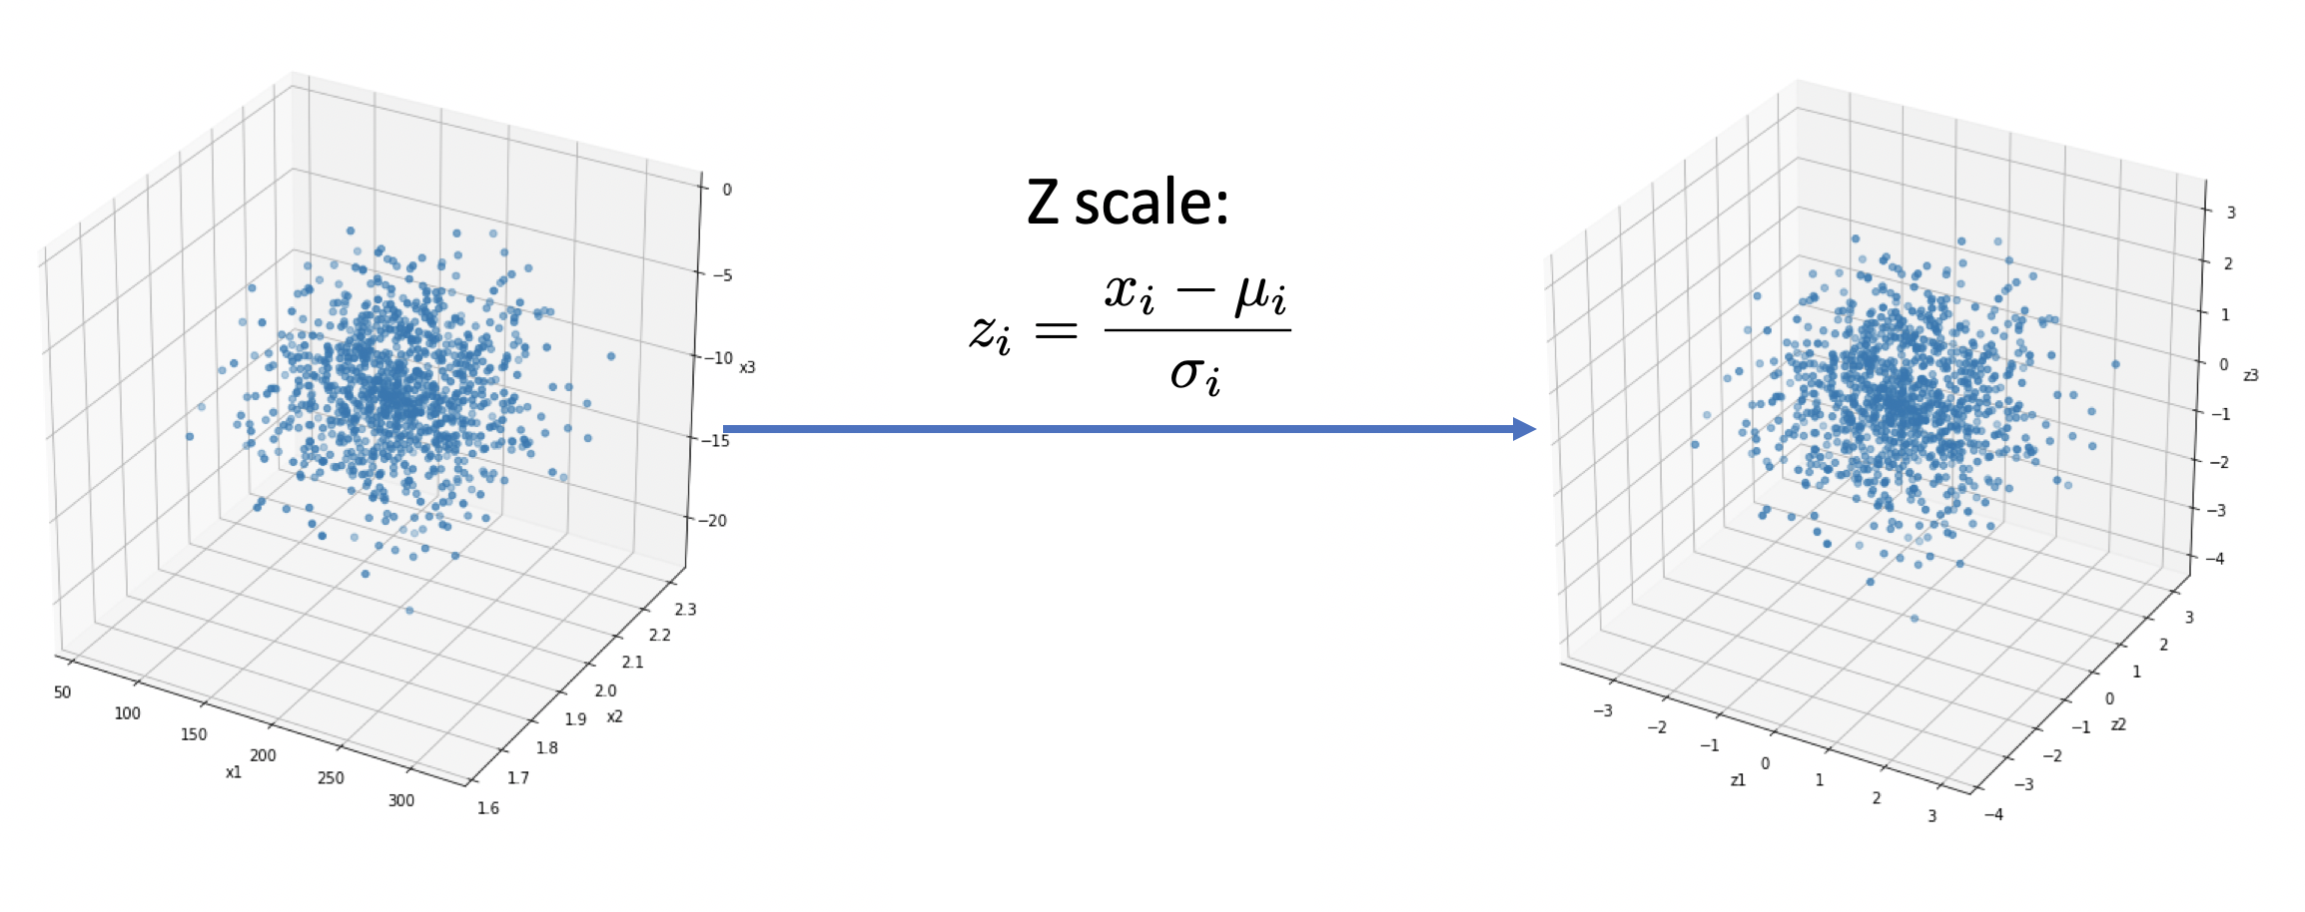

In this project, we used the PCA function from sklearn.decomposition package. We put six as the number of our PCA output dimensions. These six dimensions consist of 91.62% of the total variance.

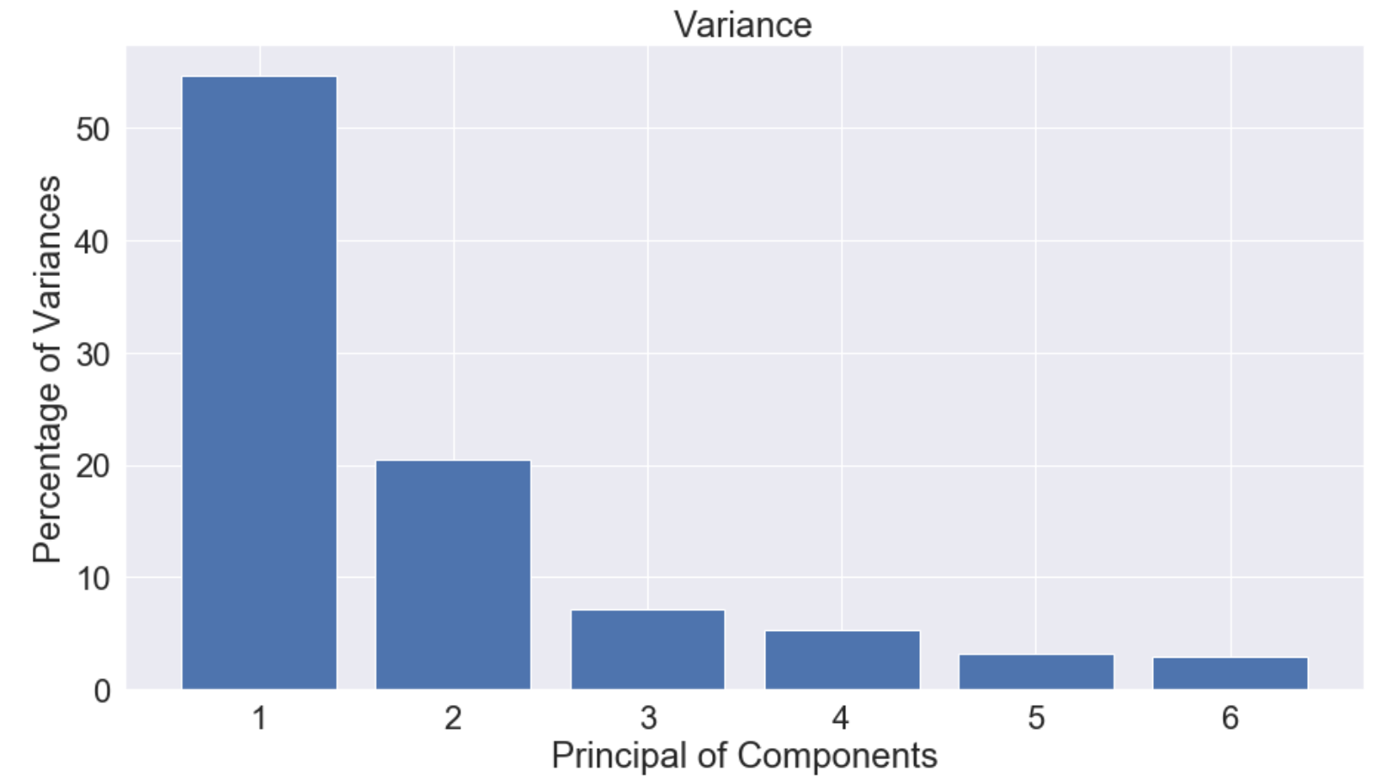

# 6. **Algorithms**

**Method 1**: Heuristic Function of z-scores

The assumption of method 1 is advantage of using heuristic function of z-scores

Steps of using z-scores to derive the fraud score:

1. Second z-scaling makes each PCA component equally important.
2. Square and sum up each record.
3. Compute the square root of the summations and rank the score descendingly.

The formula for Method 1 is shown as below:

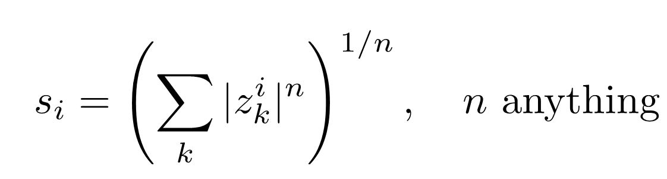

An Euclidean score (n = 2) is chosen to use the square underline the anomaly from other records. When n = 1, abnormality is not as prominent as of n = 2. We are also interested in the distribution of the scores for Manhattan score (n = 3) and a similar distribution was derived.

Method 1 generates a score for each record, which is represented as s1 later in the report.

**Method 2**: Autoencoder

Used autoencoder as a model trained to output the original vector input. If the record has no anomaly, then the new output should be similar to the original one. Otherwise, it indicates there is something unusual.

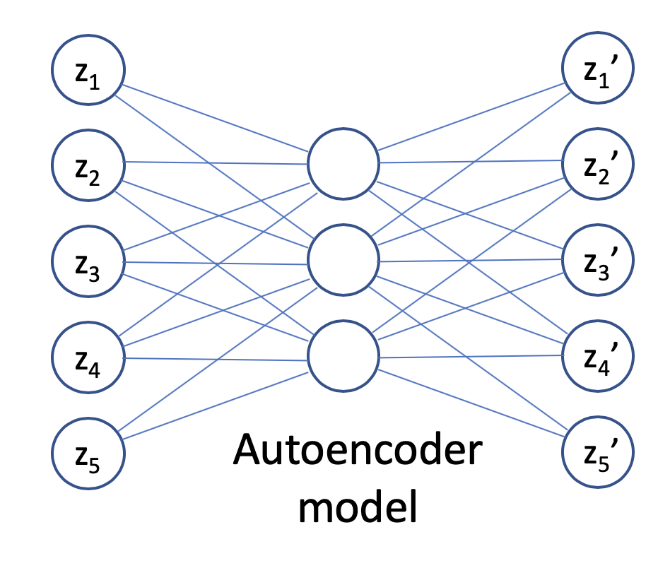

Steps of using autoencoder algorithm to get the fraud score:

1. Train an autoencoder on the entire data set by using scaled PCA.
2. The model will learn as best as possible to reproduce the data records.
3. The reproduced records that are very different from the original records are unusual.
4. Measure the reproduction error as the formula below (here we use n=2):

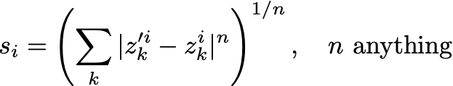

Method 2 also generates a score for each record, which is represented as s2 later in the report.

**Combining Two Scores: Quartile Binning**

Now we have generated two fraud scores from two different methods. We decided to combine them together to get a more accurate final score. Since the original two fraud scores are on different scales, it is critical for us to first re-scale them. Here we used the quantile binning method. We replaced the score with the record’s rank order after sorting by the score. Then we take the average of these two ranks to get the final score.

# 7. **Results**

**7.1 Score Distributions**

The following graphs show the distributions for s1, s2 and combined final score.

**Distribution of s1**

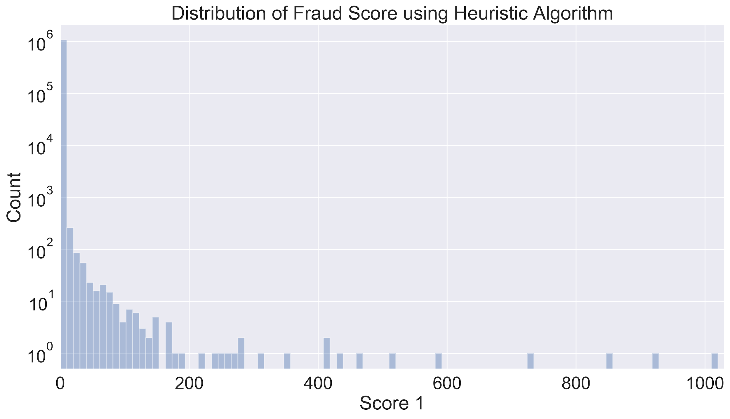

We found that more than 98.5% of s1 values are smaller than 1, so here we also drew the distribution of s1 when we set x limit between 0 and 1:

**Distribution of s1 with xlim(0,1)**

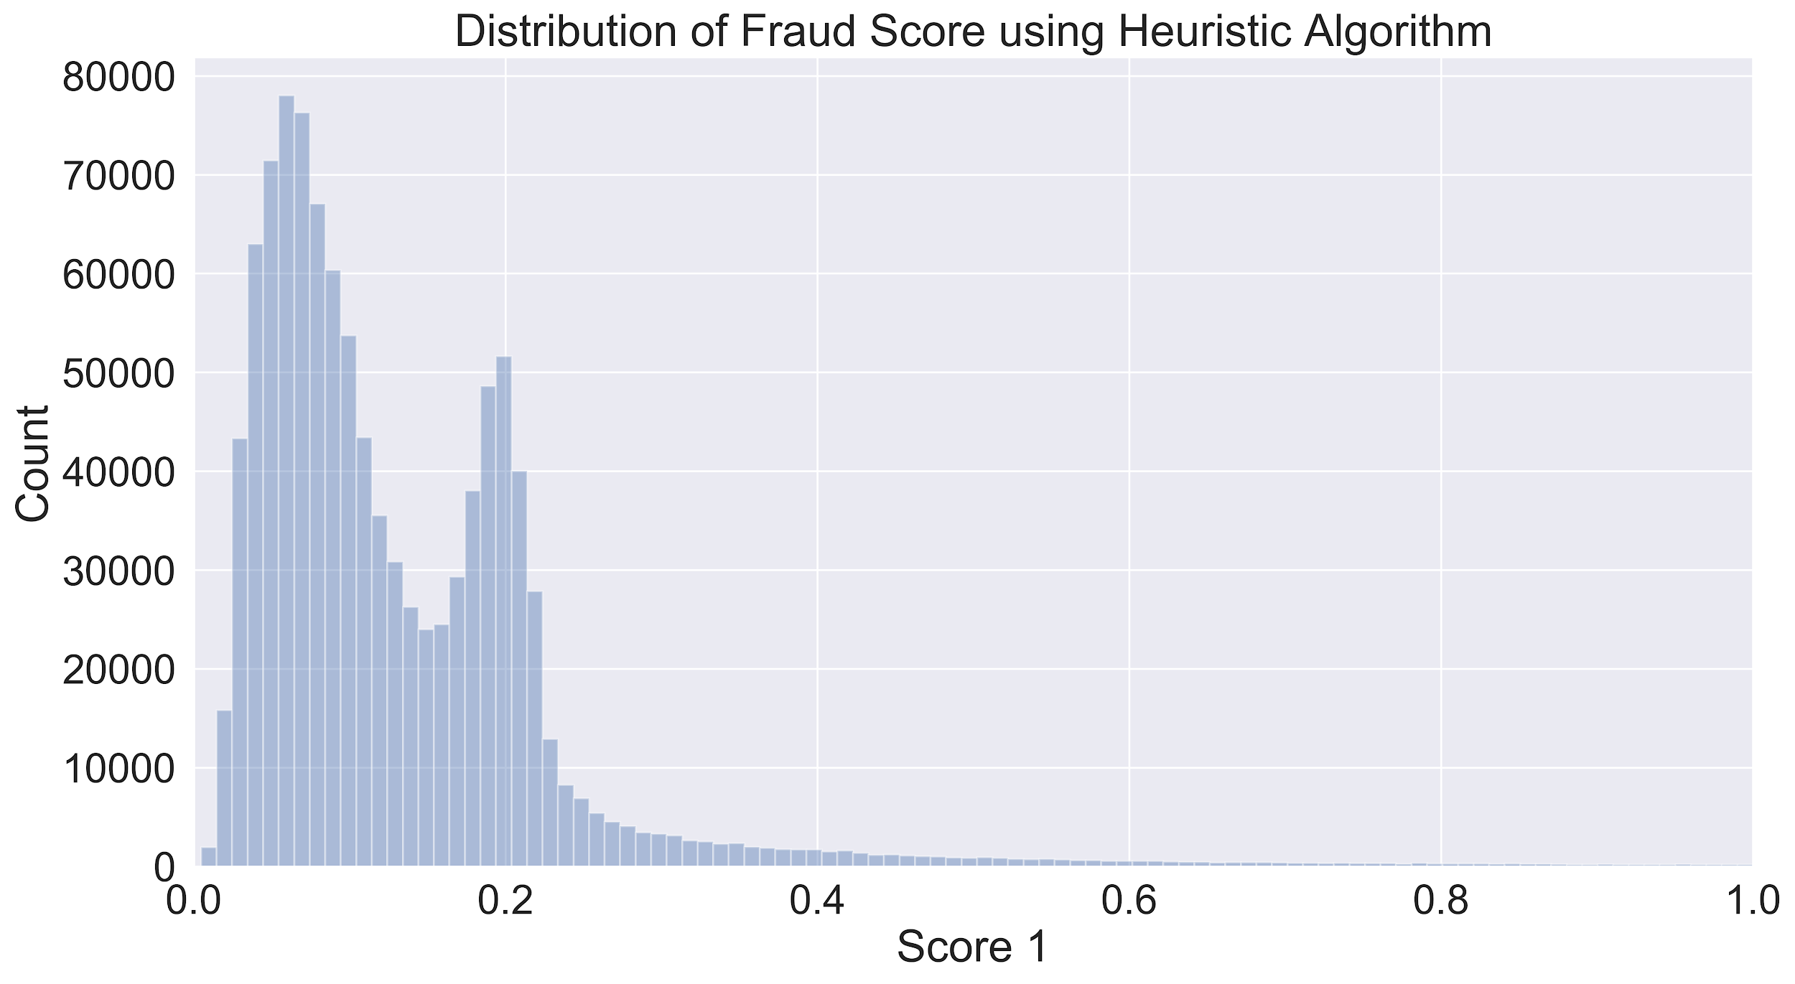

**Distribution of s2**

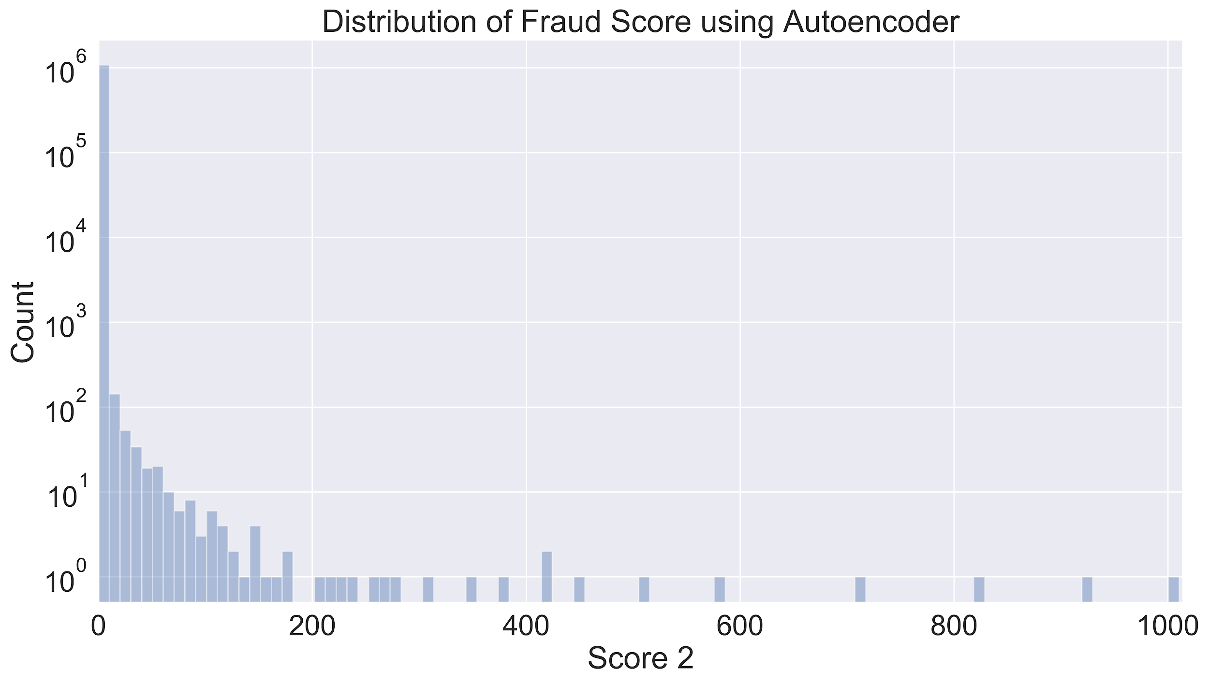

We found that more than 99% of s2 values are smaller than 1, so here we also drew the distribution of s2 when we set x limit between 0 and 1:

**Distribution of s2 with xlim (0,1)**

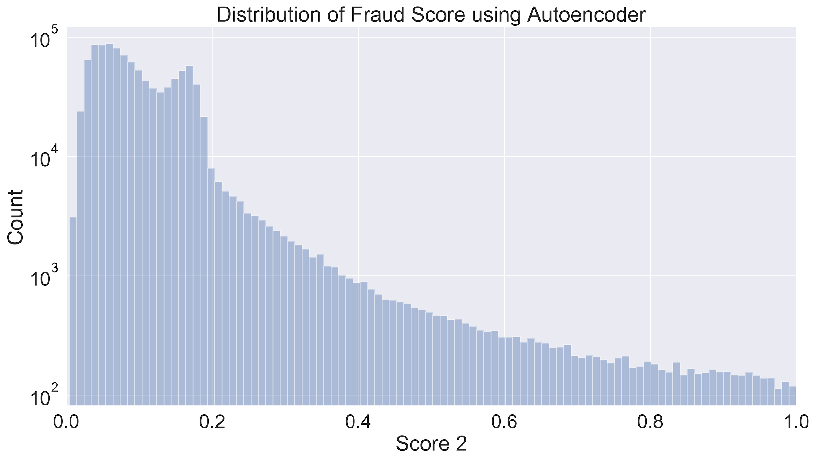

**Distribution of Combined Score**

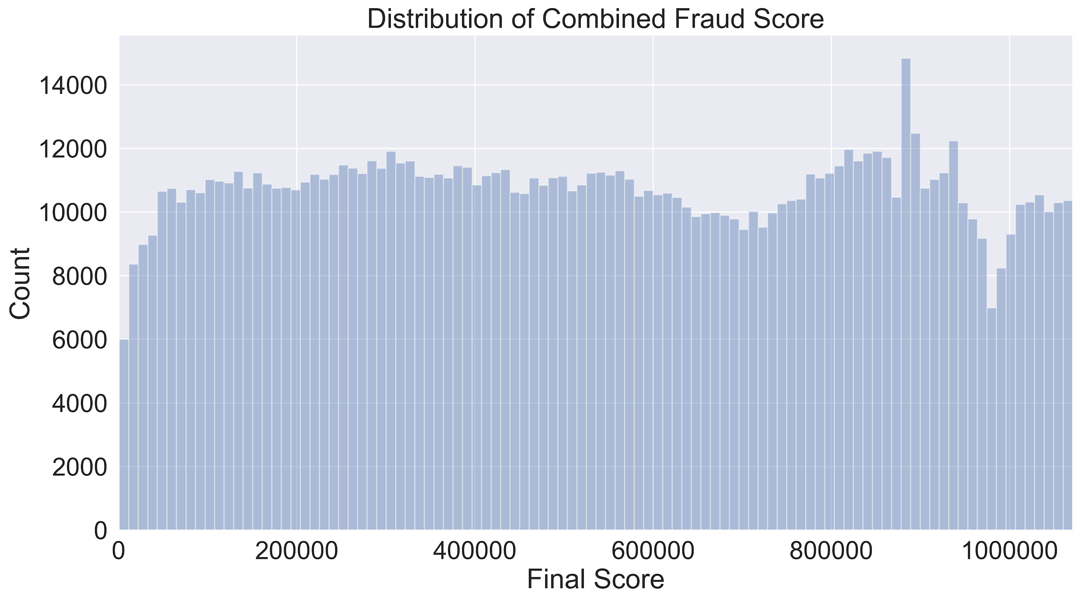

After completing the above steps, a list of top ten records with the highest fraud score is generated. The records are 632816, 565392, 1067360, 917942, 585118, 585439, 85886, 585120, 67129, 565398, ranked by the combined score starting from the highest.

**7.2 Top Ten Properties: Research & Explanations**

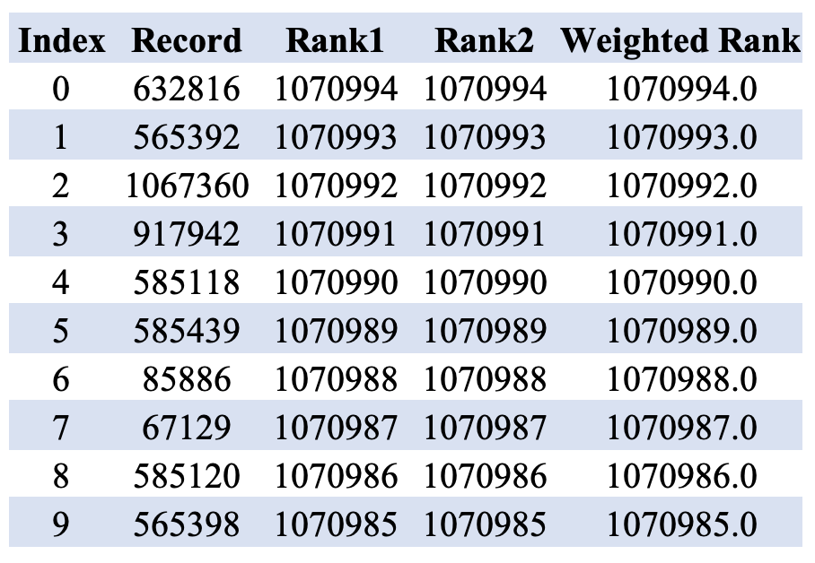

1. **RECORD: 632816**

**Original data record**

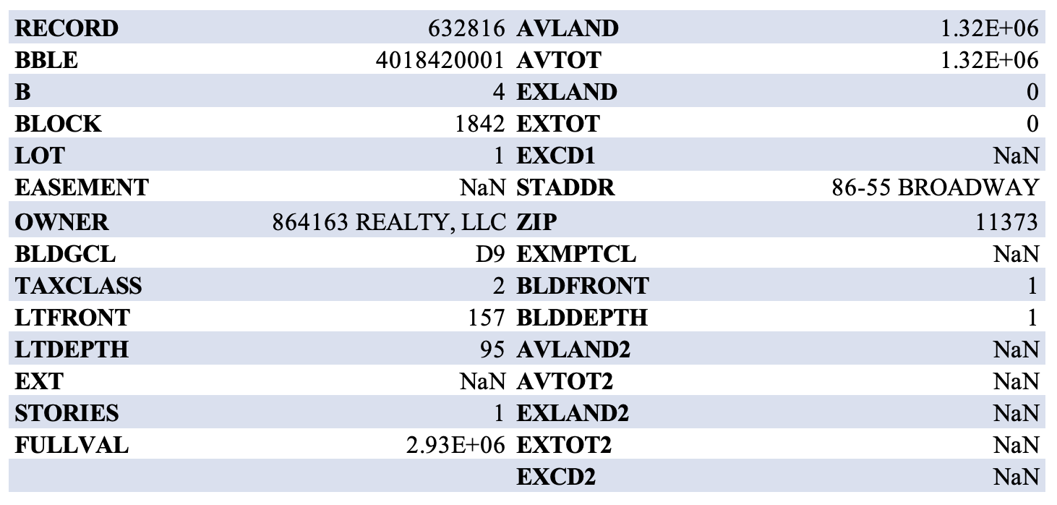

When we looked at this address on the map, we found it is a five-stories luxury apartment. According to the information above, it does not make sense to have both BLDFRONT and BLDDEPTH equal to 1, while LTFRONT and LTDEPTH equal to 157 and 95 respectively. Therefore, when we used BLDFRONT and BLDDEPTH to calculate s2, we would get an s2 that equal to 1. As a result, r2, r5, r8 would be much larger than it should be. The value of s3 is also inaccurate since it equals to s2*stories, which renders r3, r6, r9 relatively large. Therefore, record 632816 is suspicious and we suggest further investigation.

1. **RECORD: 565392**

**Original data record**

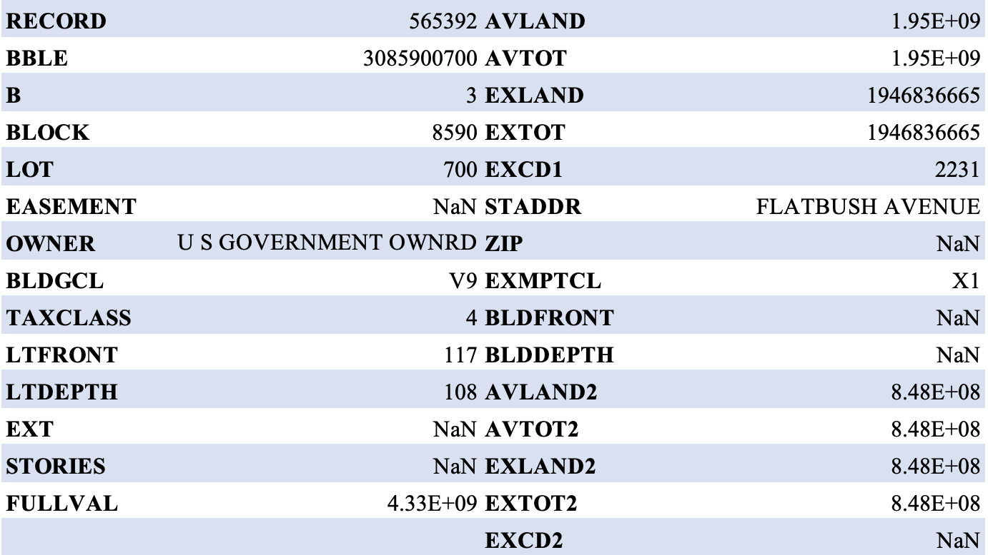

**Filled-in data record**

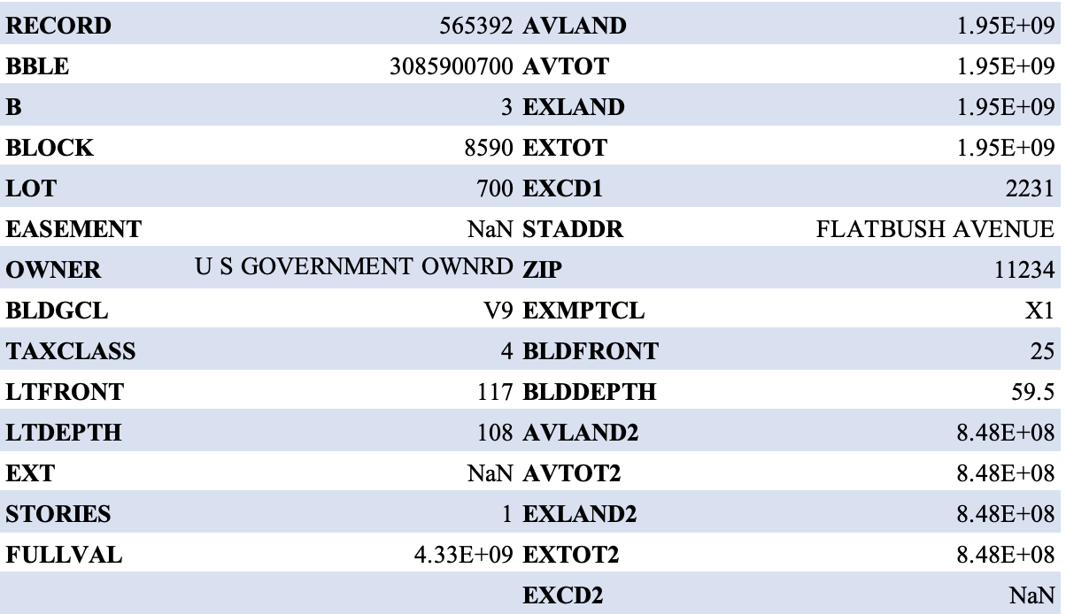

The property with a record number of 565392 is a US Government-Owned Property with an extremely high market value (third highest market value in this dataset) and low LTFRONT and LTDEPTH. There are also no Stories, BLDFRONT, and BLDDEPTH and we filled in the missing value using the median of other available data. In our created values, since we filled in stories with value 1, which drove up the r6 [AVLAND/(BLDFRONT*BLDDEPTH*STORIES)] and caused the fraud score to be extremely high. We assume that this is an empty lot that has not been used for construction, thus, this property with a high anomaly score may not necessarily refer to fraud.

1. **RECORD: 1067360**

**Original Data Record**

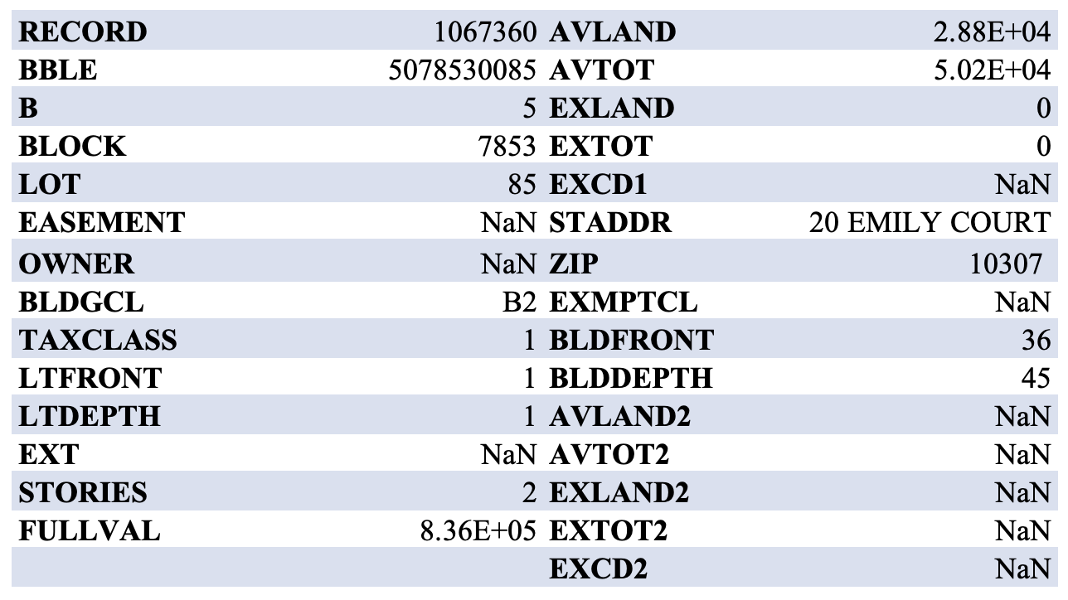

**Google Map**

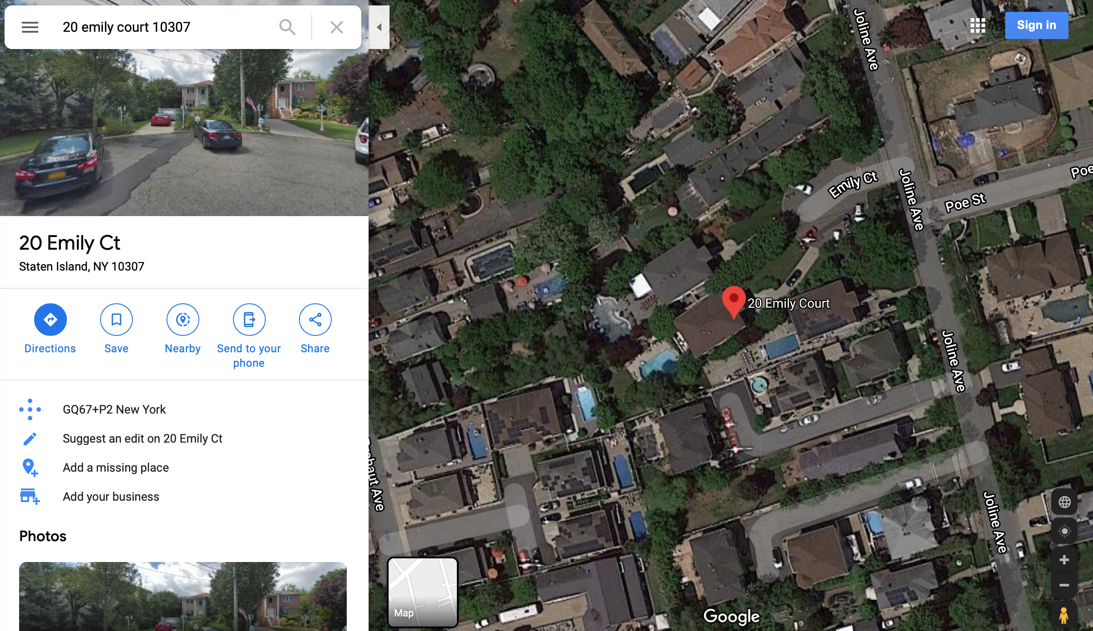

For record number 1067360, it is a residential building with 2 stories. And the information matches with the numbers on Zillow for this property (<https://www.zillow.com/homedetails/20-Emily-Ct-Staten-Island-NY-10307/58579273_zpid/>). The value of LTFRONT and LTDEPTH are both 1, which makes the denominator smaller and causes a higher variables score ($r_{1} - r_{3}$) and a high fraud score. In addition, the value of AVTOT is unusually much lower than FULLVAL. As the trading information on Zillow, this property was sold at $234,000 in 1999. The value of this property is much higher than $28,800 (AVTOT). As for a residential property, the value of the frontage lot does not seem reasonable. We think this is the main reason that caused the high fraud score. Therefore, record 1067360 is suspicious and we suggest a further investigation.

1. **RECORD: 917942**

**Original Data Record**

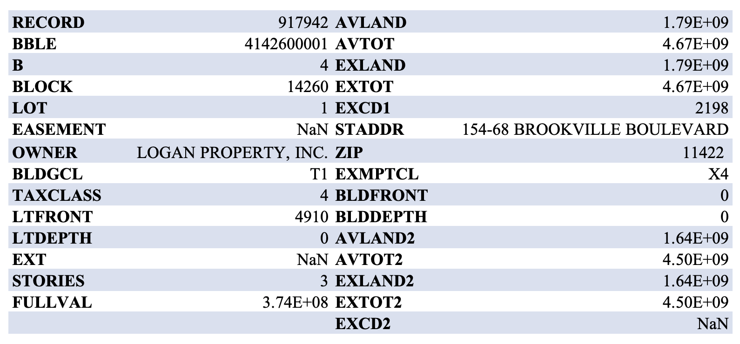

**Filled-in Data Record**

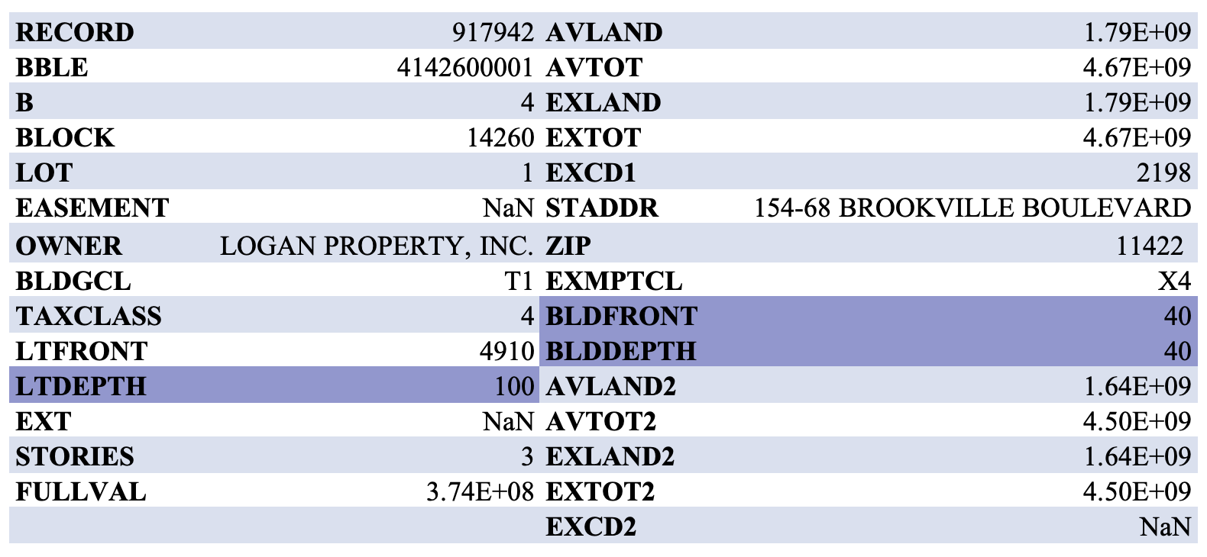

**Google Map**

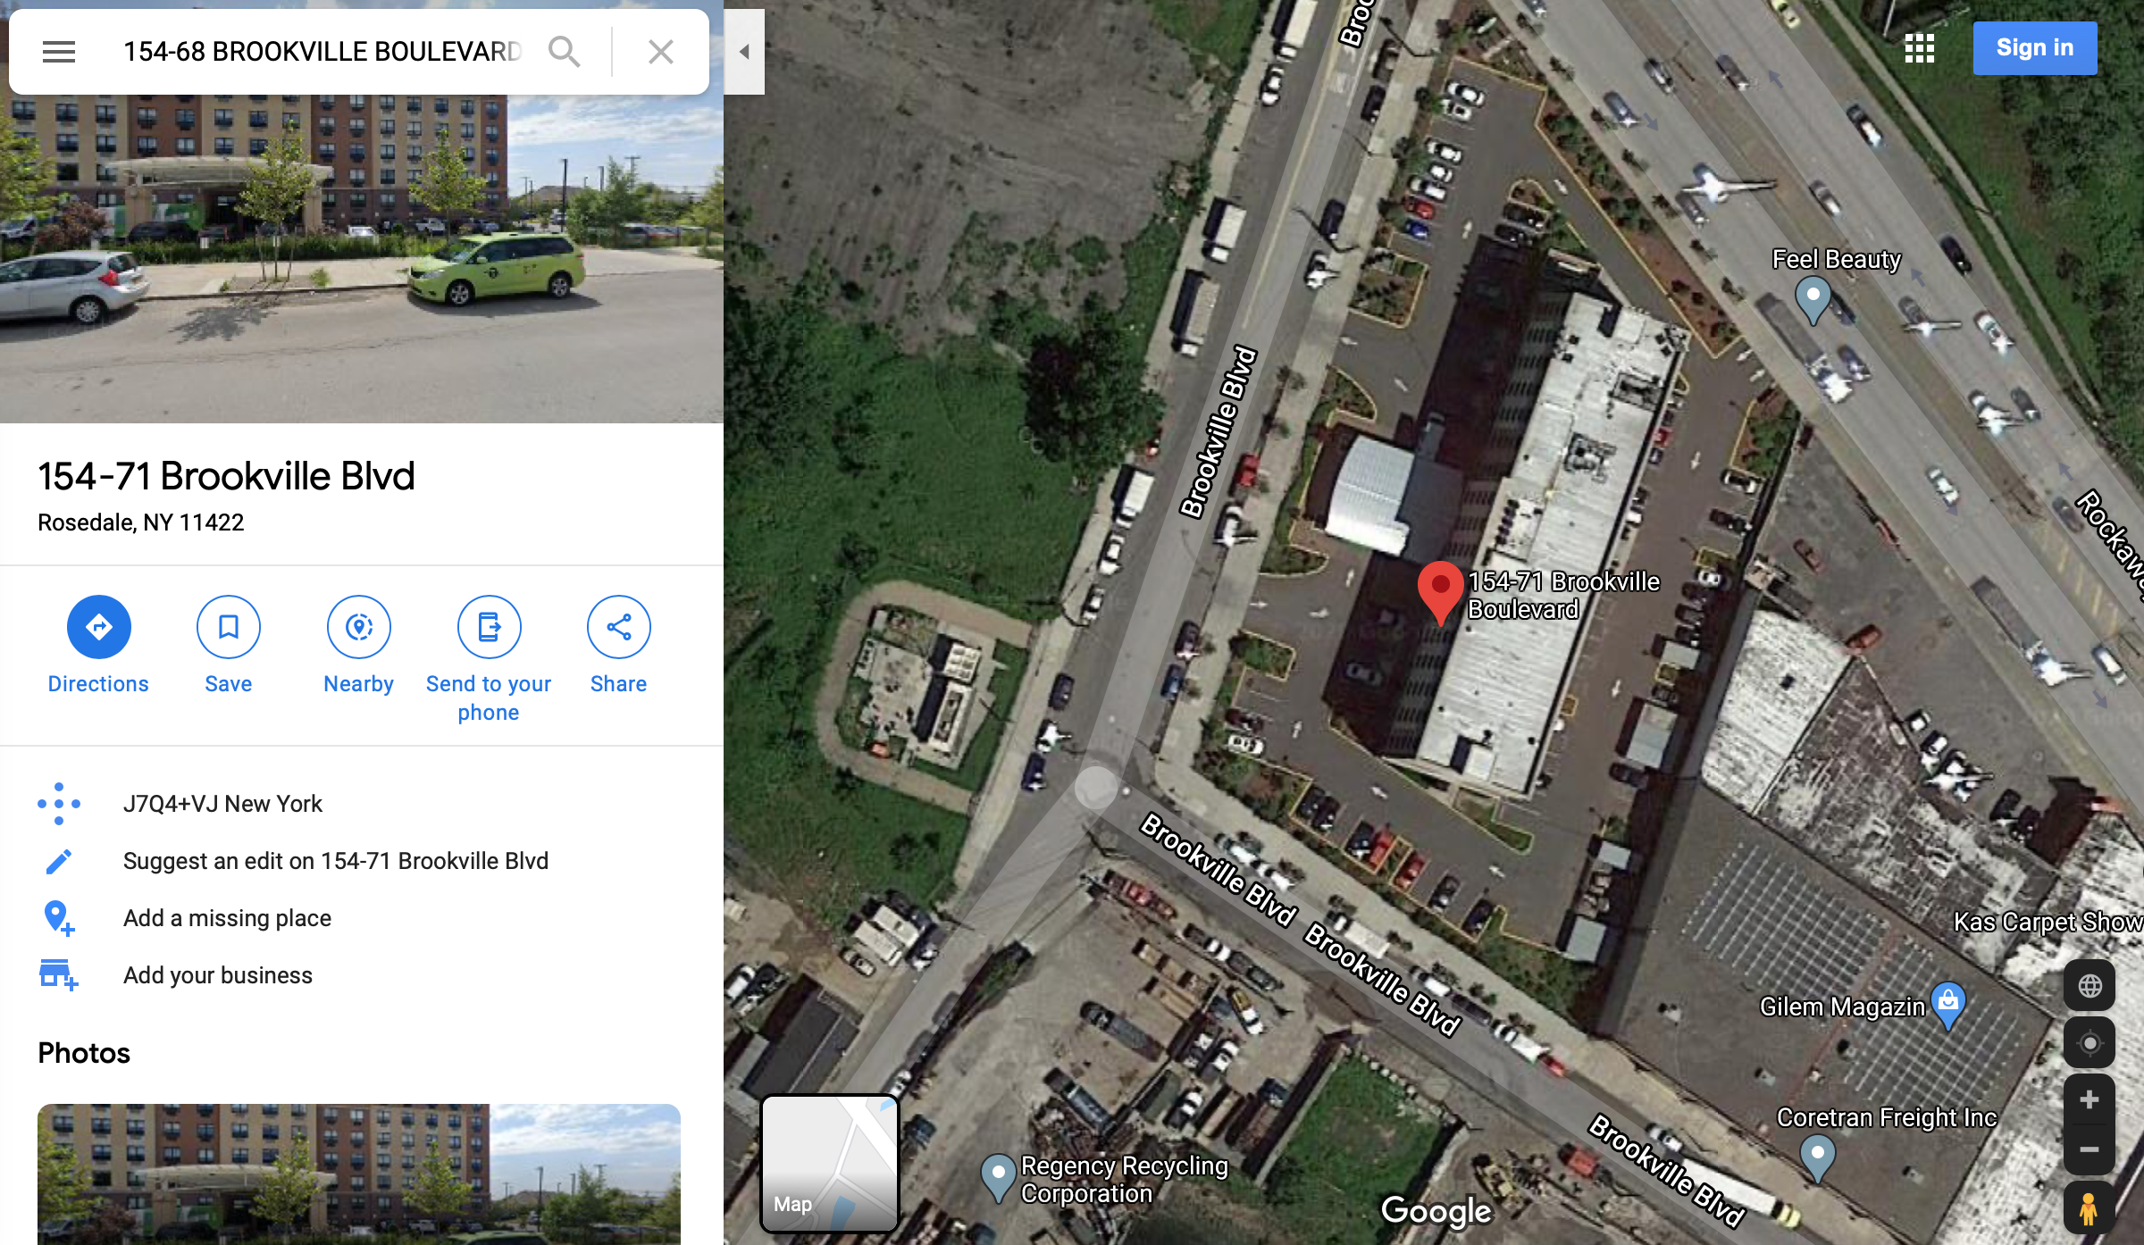

For record number 91742, as in profile, is an independent building with 3 stories, owned by LOGAN PROPERTY, INC. In the original data, three crucial variables (LTDEPTH, BLDFRONT, BLDDEPTH) contain value 0. After filling in the value according to the method described above, LTDEPTH = 100 feet, BLDFRONT = 40 feet, BLDDEPTH = 40 feet, which is extremely low compared with LTFRONT value. This low number would cause the relatively high value to all of our 9 variables ($r_{1} - r_{9}$) since the denominators are all involved with LTDEPTH, BLDFRONT, BLDDEPTH, and the numerators are the full value and other values of this property which are really high numbers. This would make the fraud score unusually high. The Google Map also shows there are 6 floors in this building which doesn’t match with the record in our profile. Therefore, record 91742 is suspicious and requires further investigation.

1. **RECORD: 585118**

**Original data record**

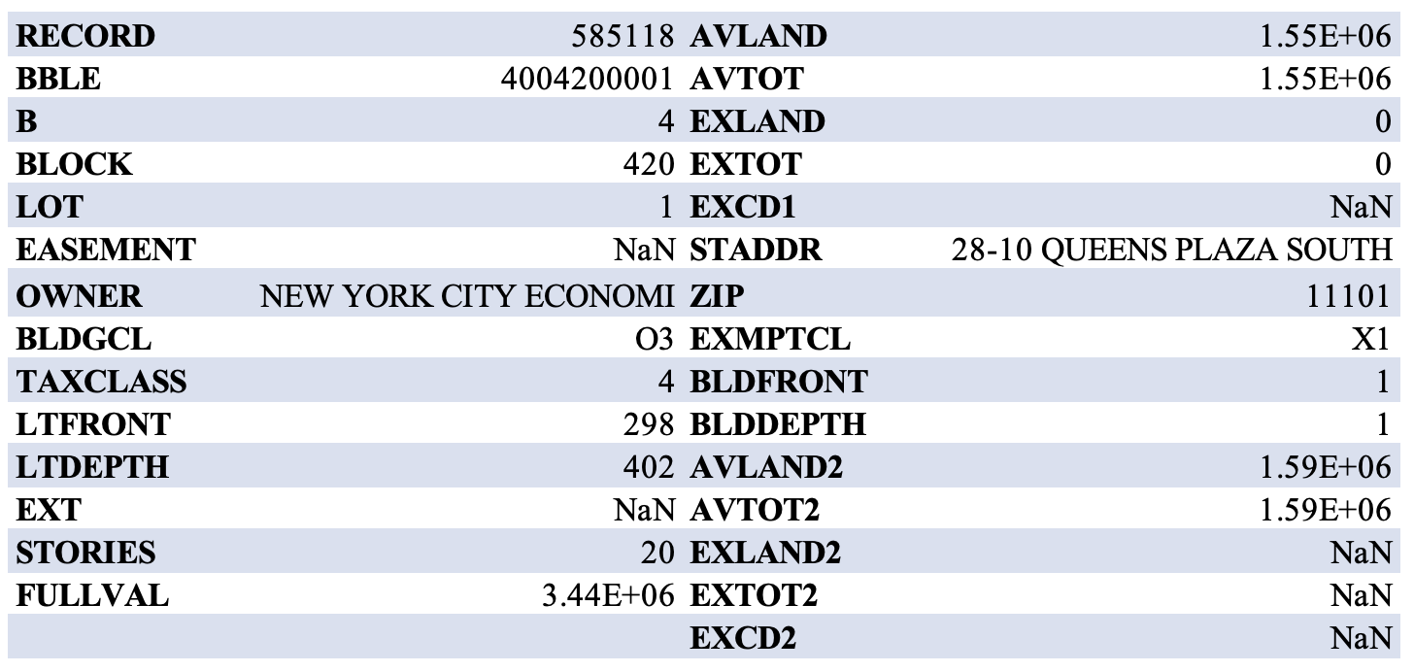

**Google Map**

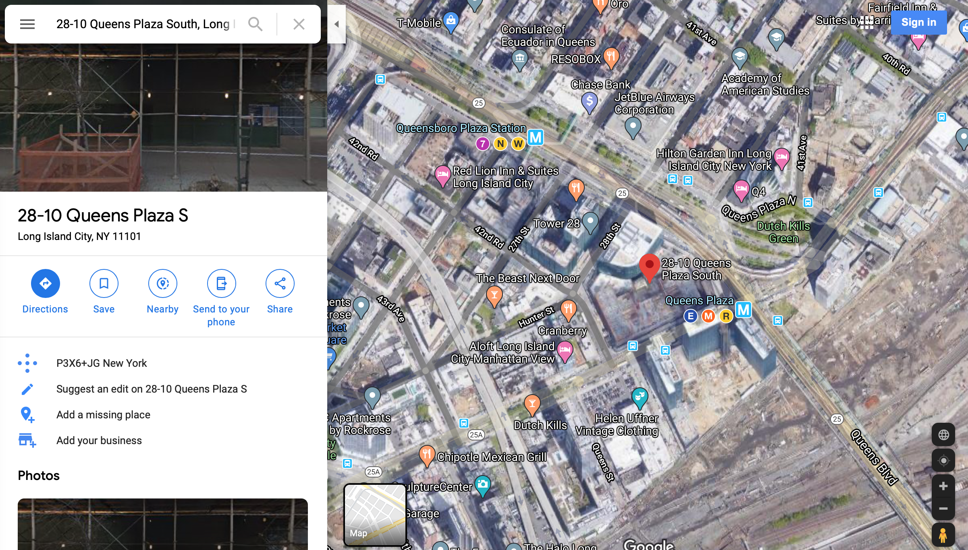

For record number 685118, there isn’t any zero or missing value that we need to fill in. According to our profile, this property is a building with 20 stories, owned by NEW YORK CITY ECONOMI. As we checked the satellite through Google Map, it is an independent building located in Queens Plaza. Compared with our data, the values of LTFRONT and LTDEPTH are within a higher range but reasonable (Refer to LTFRONT and LTDEPTH distribution in DQR in appendix). However, the values of BLDFRONT, BLDDEPTH are 1, which are not reasonable for such a huge building. These low values will cause some ( $r_{2}=\frac{V_{1}}{S_{2}}$, $r_{5}=\frac{V_{2}}{S_{2}}$, $r_{8}=\frac{V_{3}}{S_{2}}$, $r_{3},r_{6},r_{9}$, $S_{2}=BLDFRONT*BLDDEPTH$) of our 9 variables to be unusually high, which might be the reason for ramping up to a high combined score. In addition, we also found some information against our profile. According to information from StreetEasy website, this building was built in 2017 with 27 stories (<https://streeteasy.com/building/28_10-queens-plaza-south-long_island_city>). Therefore, based on the investigation, record 585118 is suspicious and requires further investigation.

1. **RECORD: 585439**

**Original Data Record**

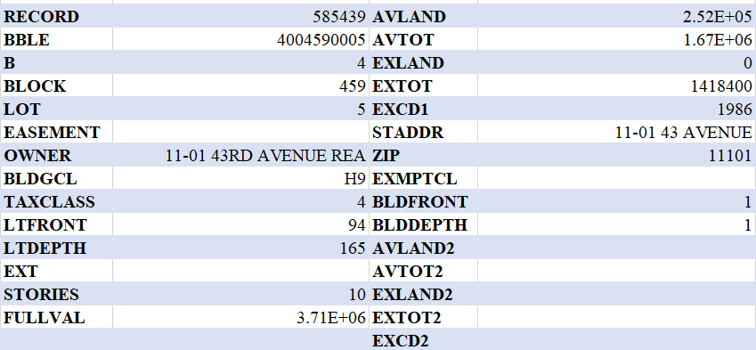

**Filled-in Data Record**

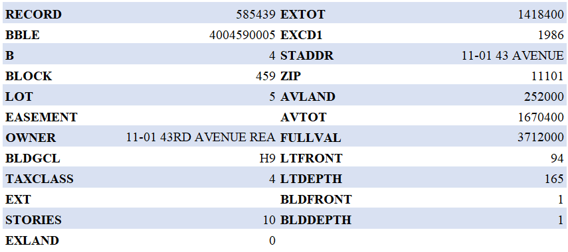

**Google Map**

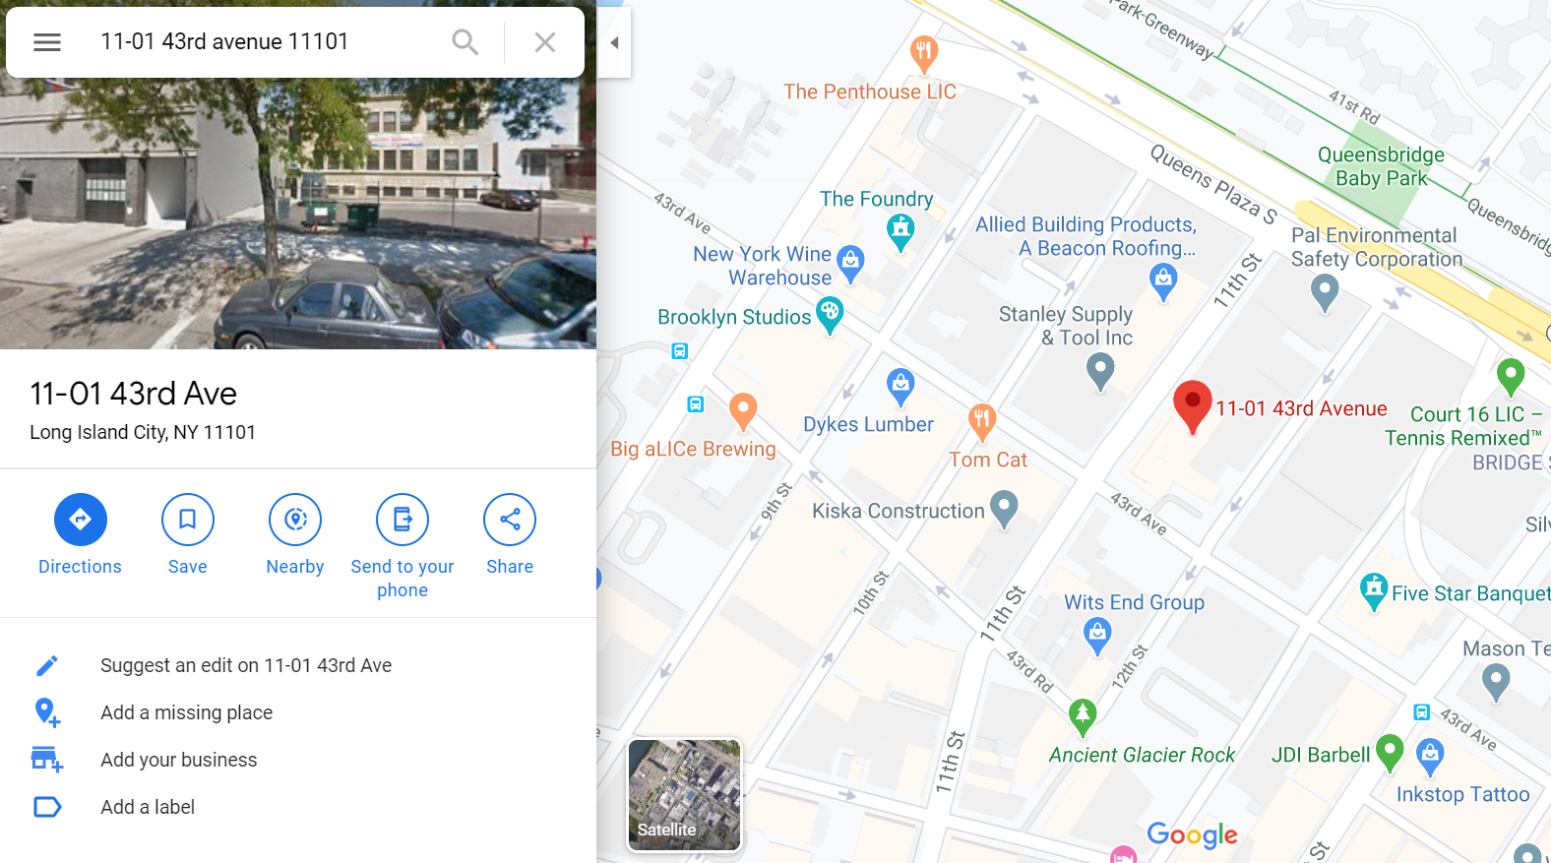

This record is categorized as “abnormal” and has a high combined total score mainly because the values of BLDFRONT and BLDDEPTH equal to 1. Large r2, r3, r5, r6, r8 and r9 are derived from these two small denominators.

Further investigation reveals that this property is a hotel built in 2011, the year the data was collected from the merchant. Looking into other records with BLDFRONT and BLDDEPTH equal to 1 from the top 10 list, we discovered that these properties were all constructed in or after 2011, suggesting that the BLDFRONT and BLDDEPTH were left as 1 because of uncertainty rather than potential fraud.

1. **RECORD: 85886**

**Original Data Record**

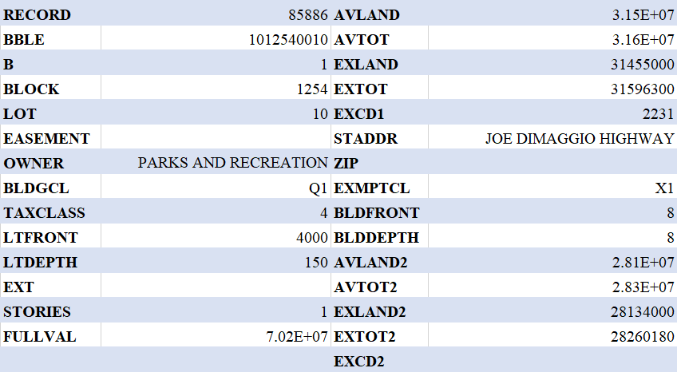

**Filled-in Data Record**

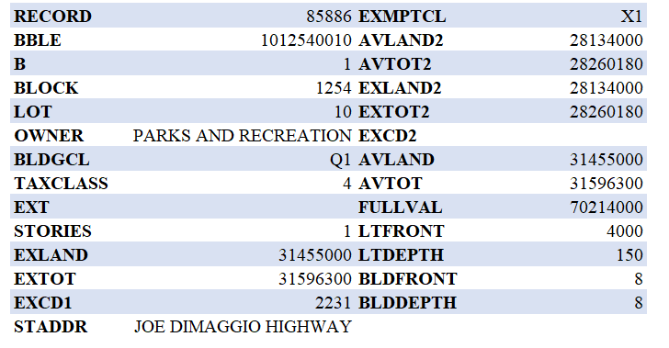

**Google Map**

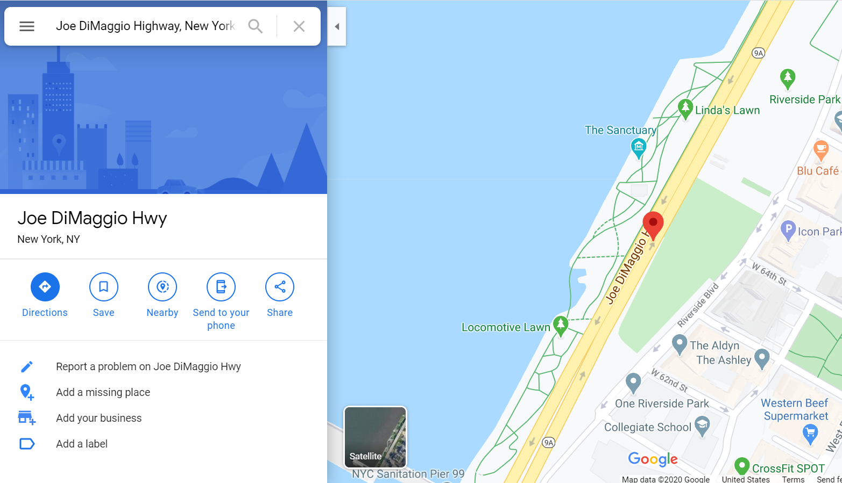

This property has unusually large AVLAND and AVTOT. Together with a relatively low BLDFRONT and BLDDEPTH, the r2 to r9 are distorted. The STADDR is not informative as Joe DiMaggio Hwy is a 5.2-mile highway and no further information can be traced from the owner, the NYC Park and Recreation Department. Since the property is owned by a government agency, the likelihood of fraud is small.

1. **RECORD: 67129**

**Original data record**

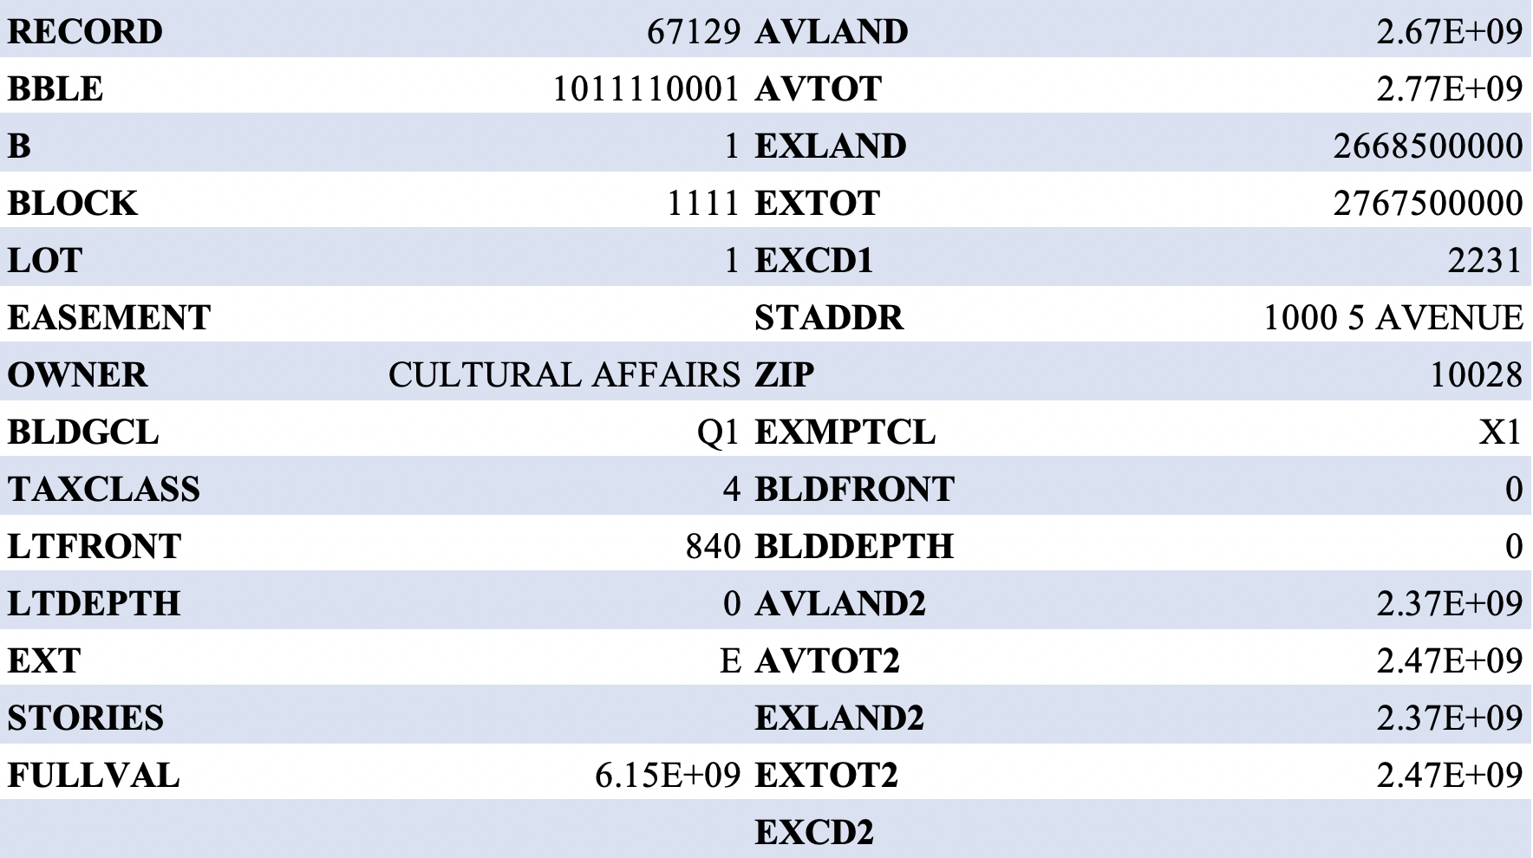

**Filled-in data record**

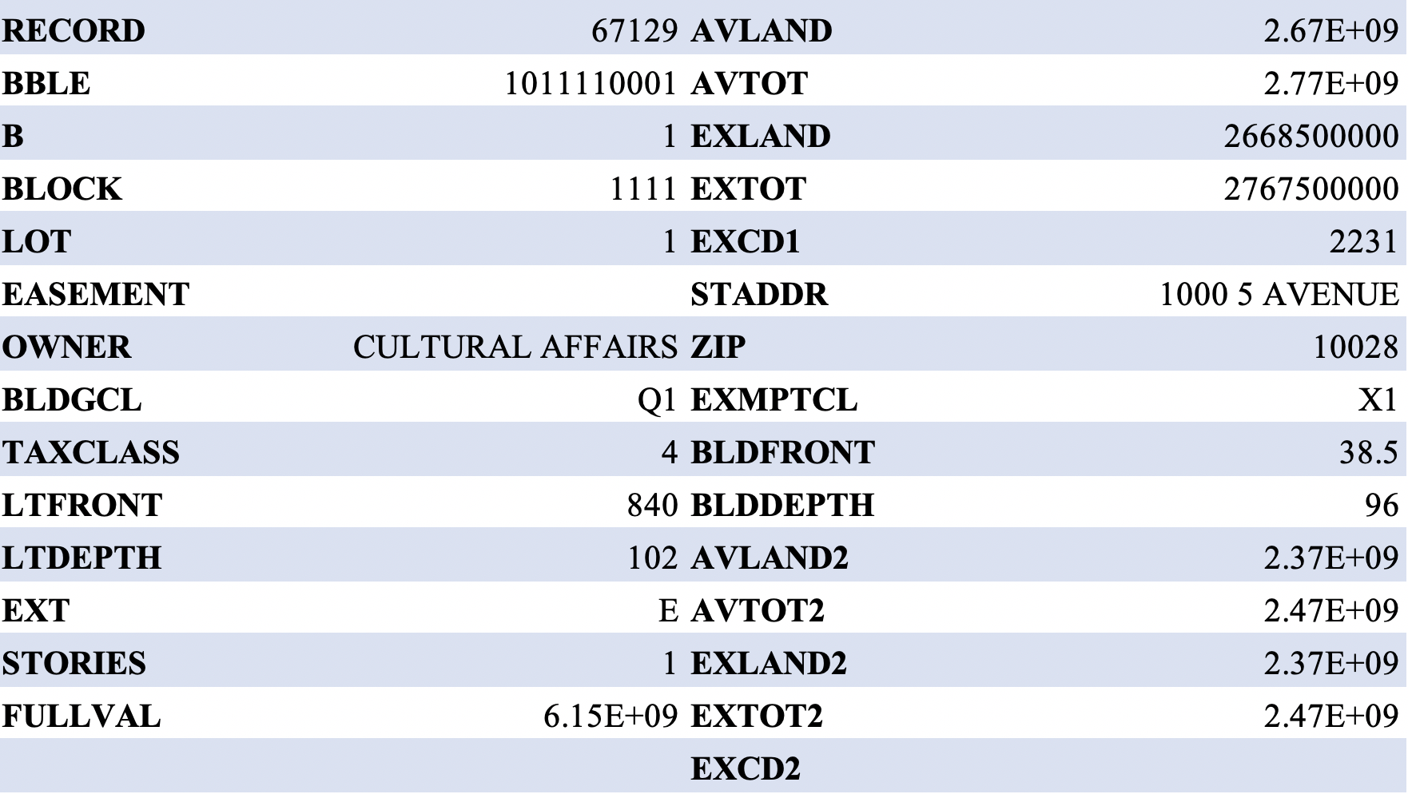

For record number 67129, it has 4 missing fields: STORIES, LTDEPTH, BLDFRONT and BLDDEPTH. The S1, S2 and S3 are relatively small since this property has a large LTFRONT. Furthermore, the FULLVAL, AVLAND and AVTOT are way higher than the average, thus r1 to r9 are extremely high.

Taken r1 as an example to illustrate the extent to which this record is comprised of 45 unusually high variables,

|  |  |  |
| --- | --- | --- |
| **Name** | **Median** | **Record 67129** |
| R1 Scaled by All | 0.714 | 337.965 |
| R1 Scaled by ZIP | 0.920 | 123.724 |
| R1 Scaled by TAXCLASS | 0.672 | 304.790 |
| R1 Scaled by B | 0.849 | 191.679 |
| R1 Scaled by ZIP3 | 0.920 | 123.724 |

According to Google Satellite, this property is the Metropolitan Museum of Art, a famous public building in New York. Further research is needed to uncover the reason for the abnormal record.

**Google Map**

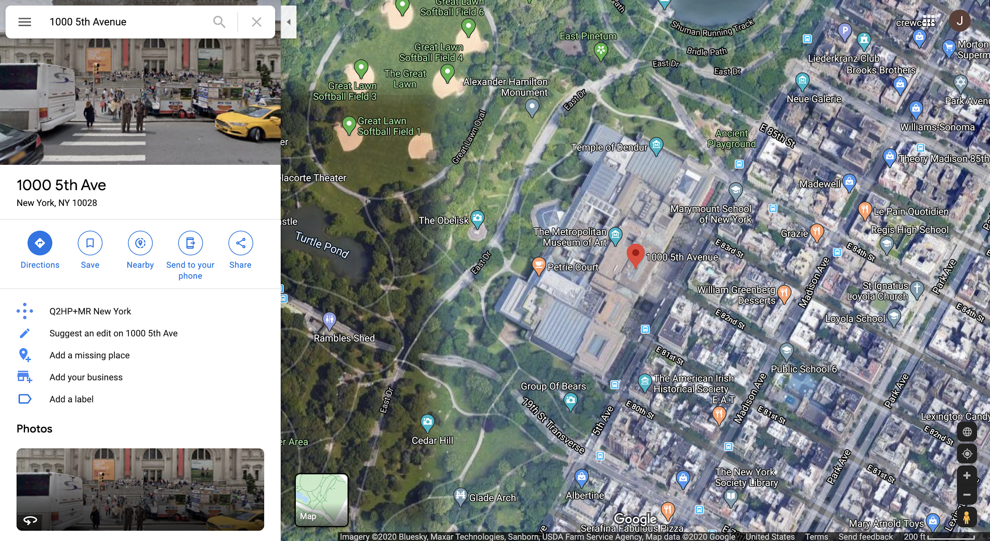

1. **RECORD: 585120**

**Original data record**

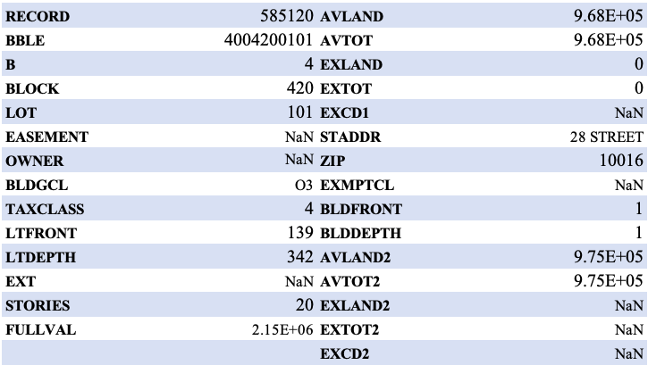

For record number 585120, there isn’t any missing value or value 0 that we needed to fill in to create expert variables. Based on the dataset, the street address for this property is 28 STREET. This seems to be an incomplete address missing either house number of street name. Therefore, it is hard for us to identify which property this record refers to exactly. From the data in record, the values for BLDFRONT and BLDDEPTH are both 1, but the value for STORIES is 20. These values seem to contradict each other since a 20-story-building should not have such small building front or building depth. Therefore, we believe this record is considered unusual since it has a vague street address and contradictory values for data available.

1. **RECORD: 565398**

**Original data record**

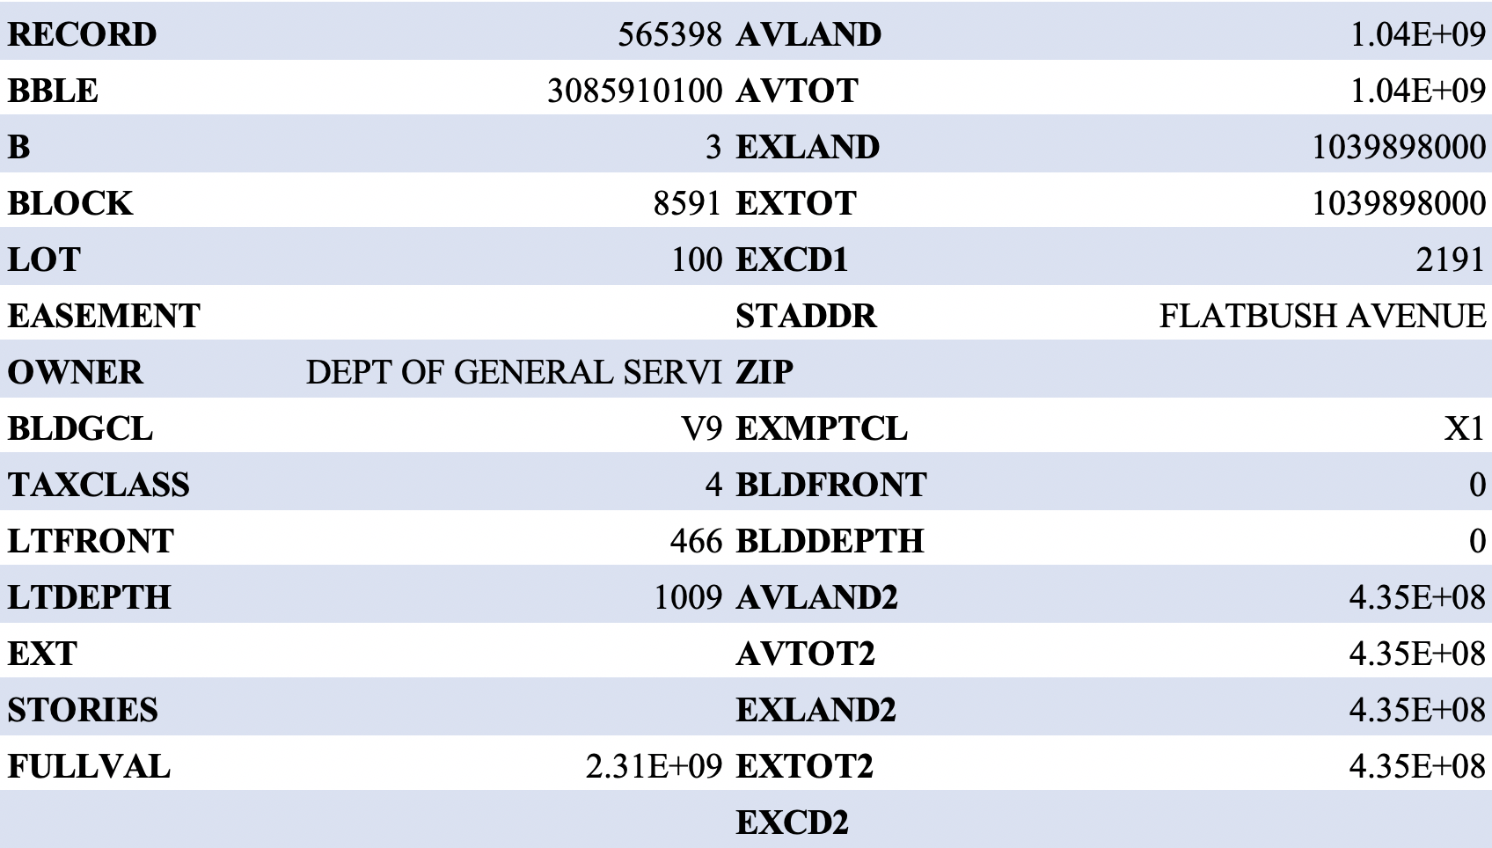

**Filled-in data record**

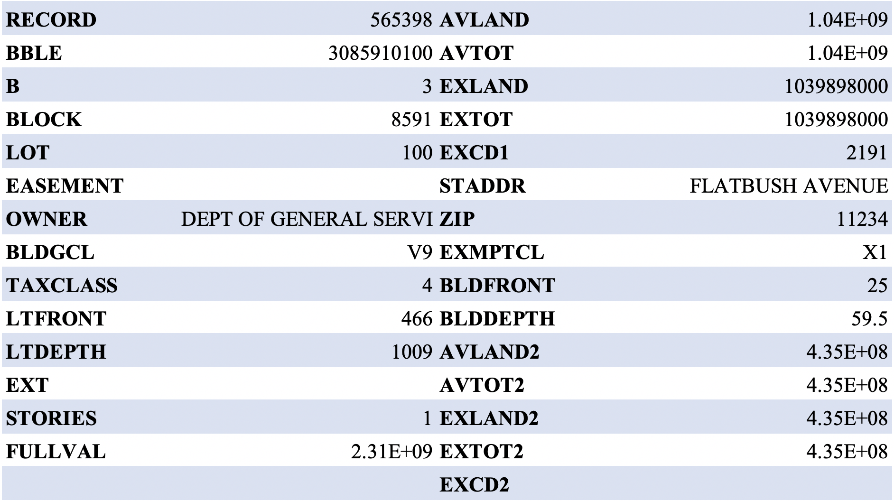

For Record 565398, it is similar to the second record in the top 10 records, Record 565392. These two records have the same address on Flatbush Avenue, which is too ambiguous to locate the property address. The property is owned by the department of general service. The reason that this record has a high fraud score is also the same as Record 565392. Its FULLVAL, AVLAND and AVLAND are extremely high, and the filled-in values are relatively small, causing extremely high values for r1 to r9 variables. Overall, we considered this property most likely to be a property owned by a government agency, so it is unlikely to be a potential fraud.

# **8. Conclusion**

In conclusion, the objective of this project is to select out anomaly records in the NY Property file and possible fraudulent ones among the anomalies. Our approach to frame this problem is to use two different models, heuristic algorithm and autoencoder, to obtain two different rankings for most potential fraudulent records and combine two rankings to get the final results. In order to do so, we first looked carefully at the data and generated a data quality report to validate the data. Then we determined how we wanted to fill in missing values/zero values with a logical approach for each field in the dataset. With all values filled, we then created 45 other variables, along with the original 9 variables we selected to use for our models. We utilized z-scaling and Principal Components Analysis to obtain our first anomaly rank and autoencoder for the second rank. Our approach helped us select the top ten properties that are most abnormal among all properties in the data set. We researched these ten properties to see if there are reasonable explanations behind their anomaly. With a conservative stand, we found that there are six out of the ten properties that we may want to look deeper into for potential property tax frauds.

If we had more time to dive deeper into this project, we would try out different methods for data cleaning and combination of aggregations for filling in missing/zero values. We noticed that using different methods for filling in missing/zero values could cause a slightly different final result. As for the second method, autoencoder, we would like to try different Python packages as we noticed that there are different codes for autoencoders. We would also like to consult with a domain expert if possible to see what variables and methods make the most sense in compliance with the industrial knowledge to develop a more realistic approach and final model at the end.